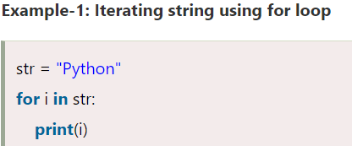

p

y

t

h

o

n

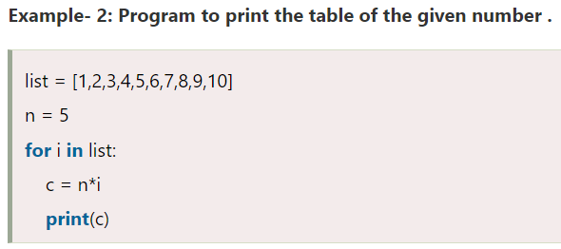

5

10

15

20

25

30

35

40

45

50

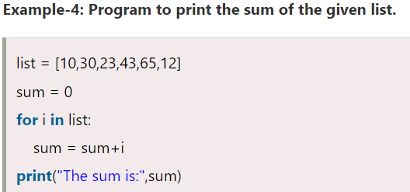

The sum is: 10

The sum is: 40

The sum is: 63

The sum is: 106

The sum is: 171

The sum is: 183

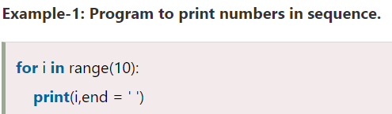

0123456789

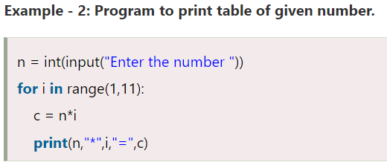

enter the number12

12 \* 1 = 12

12 \* 2 = 24

12 \* 3 = 36

12 \* 4 = 48

12 \* 5 = 60

12 \* 6 = 72

12 \* 7 = 84

12 \* 8 = 96

12 \* 9 = 108

12 \* 10 = 120



hello peter

hello joseph

hello ricky

hello devansh

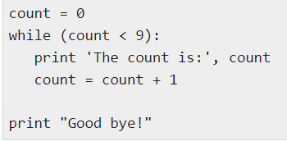

the count is: 0

the count is: 1

the count is: 2

the count is: 3

the count is: 4

the count is: 5

the count is: 6

the count is: 7

the count is: 8

good bye

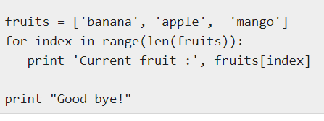

current fruits: banana

current fruits: apple

current fruits: mango

good bye

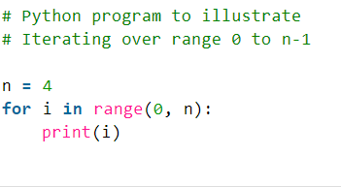

0

1

2

3

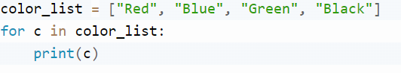

red

blue

green

black

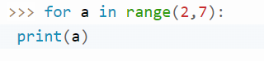

2

3

4

5

6

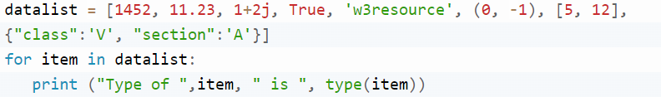

type of 1452 is <class 'int'>

type of 11.23 is <class 'float'>

type of (1+2j) is <class 'complex'>

type of True is <class 'bool'>

type of w3resource is <class 'str'>

type of (0, -1) is <class 'tuple'>

type of [5, 12] is <class 'list'>

type of {'class': 'V', 'section': 'A'} is <class 'dict'>

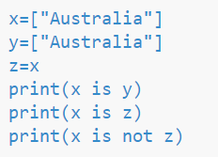

False

True

False